PRACTICAL 7

SQL queries to implements various arithmetic operators on operands and table data.

***Query1. Write SQL Query to perform * operators in the table purchase_2120 table.***

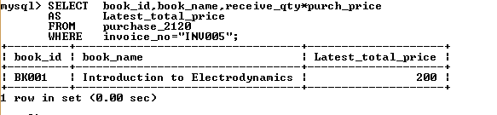

***Query2.Write SQL query to increase the book price of book 20% in book_mast_2120 table.***

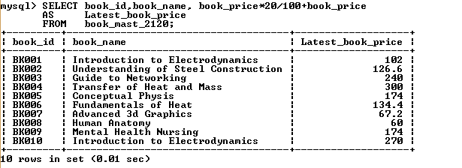

***Query3. Write SQL query to decrease the book price by 20 % in book_mast_2120 table.***

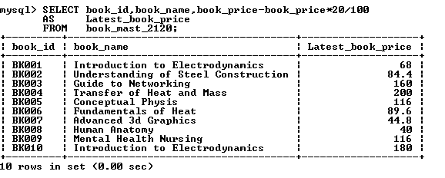

***Query4. Write SQL query to perform (*) operator to decrease the unit price of product table.***

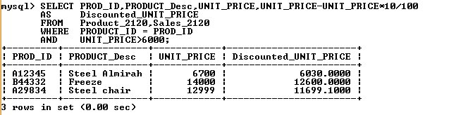

***Query5. Write SQL query to perform (+) operator to add salary to basic salary in EMP2_2120 table.***

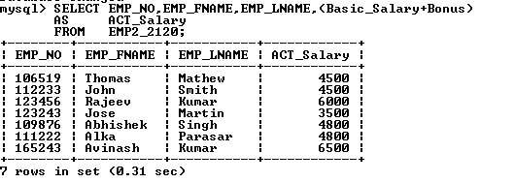

***Query6. Write SQL query to perform (-) operator to decrease salary to basic salary in EMP2_2120***

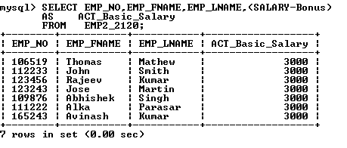

***Query7. Write SQL query to perform (*) operator to increase bonus in EMP2_2120.***

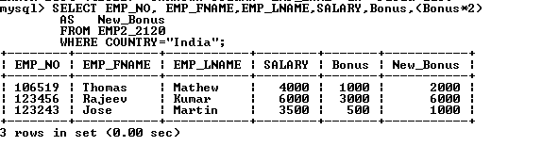

***Query8. Write SQL query to perform arithmetic operator to give 10% percent hike.***

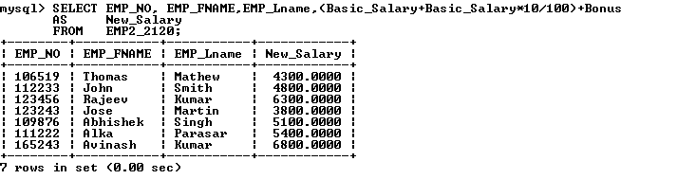**Query9**. **Write SQL query to perform arithmetic operator give 10% bonus to employee.**

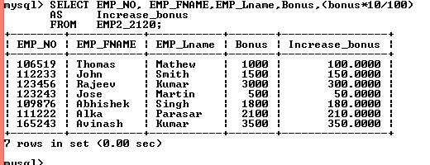

**Query10. Write SQL query to increment a salary by 33%.**

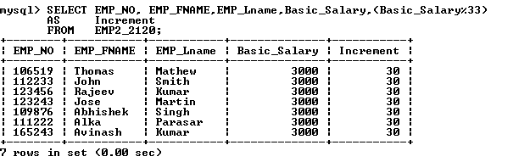

***Query11. Write SQL query to increase a 20% of book price in book mast table.***

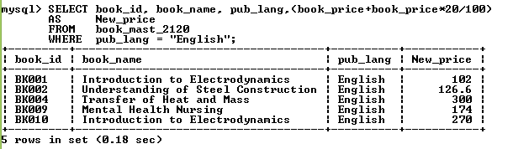

***Query12. Write SQL query to increase quantity of books by 5 and then get a new receive quantity and total price of books.***

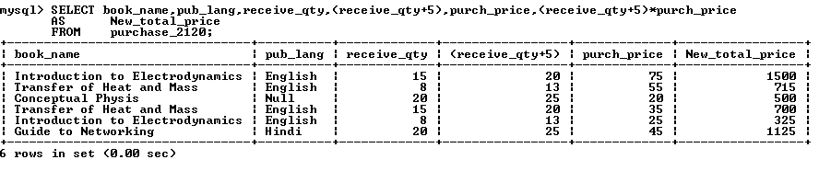***Query13.Write a SQL query to decrease a salary of employees by 10%.***

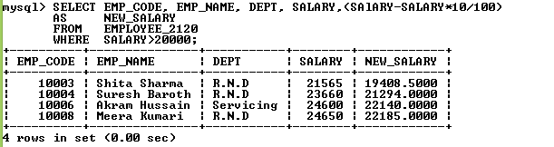

**Query14. Write a SQL query to use divide operation on the table data.**

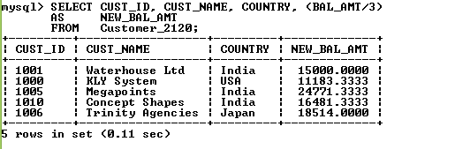14

***Query 15. Write a SQL query to increase a salary of employees by 1100 in employee tables***